[1]

Practice 3. Developing the PCB (Fabrication)

First Team Member, Second Team Member, …

*Objectives*—

**Build the minimum system from the designs that the student made on the practices 1 and 2.**

*Index Terms*—fabrication, pcb, microcontrollers.

# INTRODUCTION

M

ICROCONTROLLERS are all around the world. Each day, Microcontrollers, are more present in the many aspects of our lives: in our work, inside our houses, and in more. We can find them controlling small devices like cellphones, microwaves, washing machines, and televisions.

A microcontroller is one device or chip that is used to govern one or more processes. For example, the controller that regulates the room temperature of an air conditioner; it has a sensor that continuously measures the internal temperature and, when the preset limits are exceeded, it generates the necessary signals to adjust the temperature.

# State of the Art

## The practices and the PIC microcontroller

The main objective of this practices is to provide students the foundation to fully understand the operation of the PIC18F45K50 microcontroller. This will be achieved through 11 documents that will guide the reader to create their own electronic card or Printed Circuit Board (PCB) and to be able to program it; in order to, execute different functions.

The advantages of ta PIC microcontroller to others on the market, which is why it will be used throughout this manual, are as follows:

* Easy to operate.
* There is enough documentation to work with it and it’s easy to obtain it.
* The price is comparatively lower than its competitors.
* It has a high operating speed.
* Development tools are cheap and easy to use.
* There are a variety of hardware that can record, erase and check the behavior of PIC.
* Once you learn to handle a PIC, it will easier to handle any other models of microcontrollers.

## KiCad EDA Software

KiCad is an open source software suite for Electronic Design Automation (EDA). The programs handle Schematic Capture, and PCB Layout with Gerber output. The suite runs on Windows, Linux and macOS and is licensed under GNU GPL v3. The first release date was in 1992 by its original author, Jean-Pierre Charras, but is now currently under development by the KiCad Developers Team [1].

# Results

In this section, you must report the outcomes of the laboratory activities.

## Generate Gerber Files

1. Now that your PCB is completed, you can generate the **Gerber files** for each layer of your board. Click on Perform design rules check as shown in Fig. 1. Then click on the Run DCR, if everything goes right you will get no message of error, as show in figure 2.

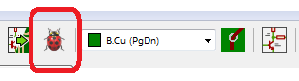

Fig. 1. Perform design rules check.

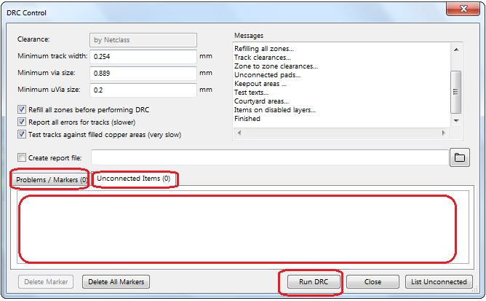

Fig. 2. DRC control.

1. Click on **File→Plot…** Select ‘**Gerber**’ as ‘**Plot Format**,’also you must choose a folder to save your generated files. Make sure that only the next options are selected: **B.Cu** from ‘**Layers**’ box, **Exclude PCB edge layer from other layers** from ‘**Options**’ box, and **Use proper filename extensions** from ‘**Gerber Options**’ box; as shown in Fig. 3.

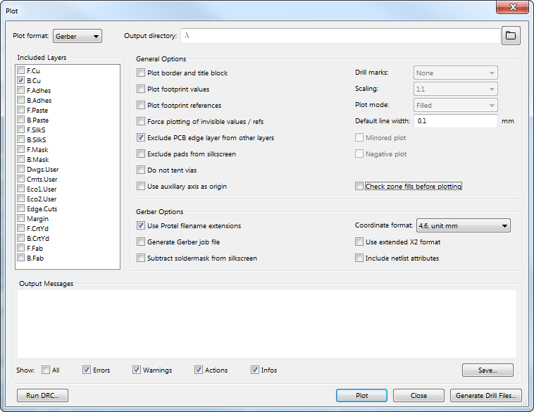

Fig. 3. Plot window configurations.

1. Finally, click on ‘**Plot**’ and then click on **Generate Drill File**. A new window will appear with some options on default. In the section **Excellon Drill File Options** select the ‘**PTH and NPTH holes in single file**’ box, then click on the button ‘**Generate Drill File**.’ Next, in the section **Drill Map File Format** change to ‘**PDF**’ box and click on ‘**Generate Drill File**’ again, see Fig. 4.

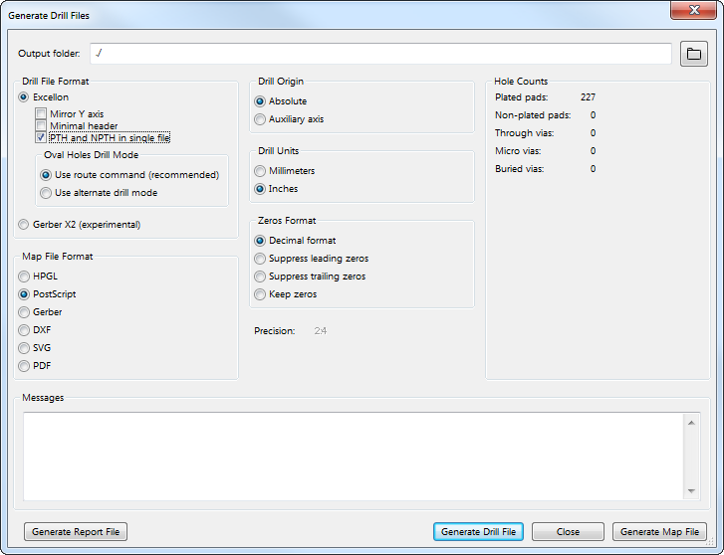

Fig. 4. Generate Drill Files window configuration.

1. Once the **Gerber** and **Drill** files are generated, you can check your track design in [2]. Use the file with the **.gbl** extension.

## PCB Manufacturing

1. Now it is time to send your PCB design for manufacturing. First, send to [labpcb@yahoo.com](mailto:labpcb@yahoo.com) the files with the extensions: **.gbl** and **.drl**. In the mail, you are going to ask for the price of manufacturing your PCB design with a CNC machine.
2. Once you have received the price of your design do the corresponding payment. The payment could be done in the virtual store or in the treasury department.
3. Once the payment has been made, go to **A7-236** and deliver the receipt and your copper clad board.
4. Finally with your manufactured PCB, start to soldering all the components in your board, as shown in Fig. 3. **When you finish soldering, test your tracks for continuity or for a short circuit with the multimeter. That is the most important step to ensurance a correct functionability of your PCB board.**

### ***Report:*** For this practice, modify only the Section IV and your names at the top of the document. Upload the modified document to Blackboard.

### ***File Uploads:*** Create a ZIP with the next file extensions: **.gbl** and **.drl**, that were created once you completed all the steps of the document. Upload the ZIP file to Blackboard.

### **Demonstration:** Take a photo of your PCB board with all the attached electronic components and upload it to Facebook. Also, show the instructor your complete PCB board.

# Conclusion

## In this section, you should add the conclusions, suggestions, and/or problems of the laboratory activities. Each team member must add his/her own conclusion (5 lines as minimum for each member).

References

1. B. Trinkel, “Fluid Power eBook- Fluid Power Basics,” in Hydraulics & Pneumatics magazine, 1st ed., Penton Media Inc., June 2007.

[2] https://www.pcbgogo.com/GerberViewer.html

1. This paragraph of the first footnote will contain the date on which you submitted your report for review.

   The next few paragraphs should contain the authors’ current affiliations, including current address and e-mail.

   Ph. D. Raúl Peña Ortega is with Tecnologico de Monterrey, as a Professor (e-mail: raul.p.ortega@tec.mx).

   M.C. Salvador Rodríguez López is with Tecnológico de Monterrey, as a Professor (e-mail: salvadorrdzlop@tec.mx).